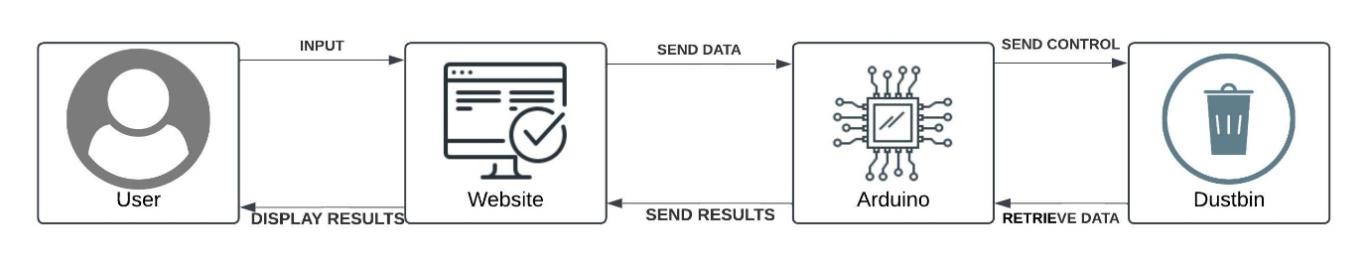

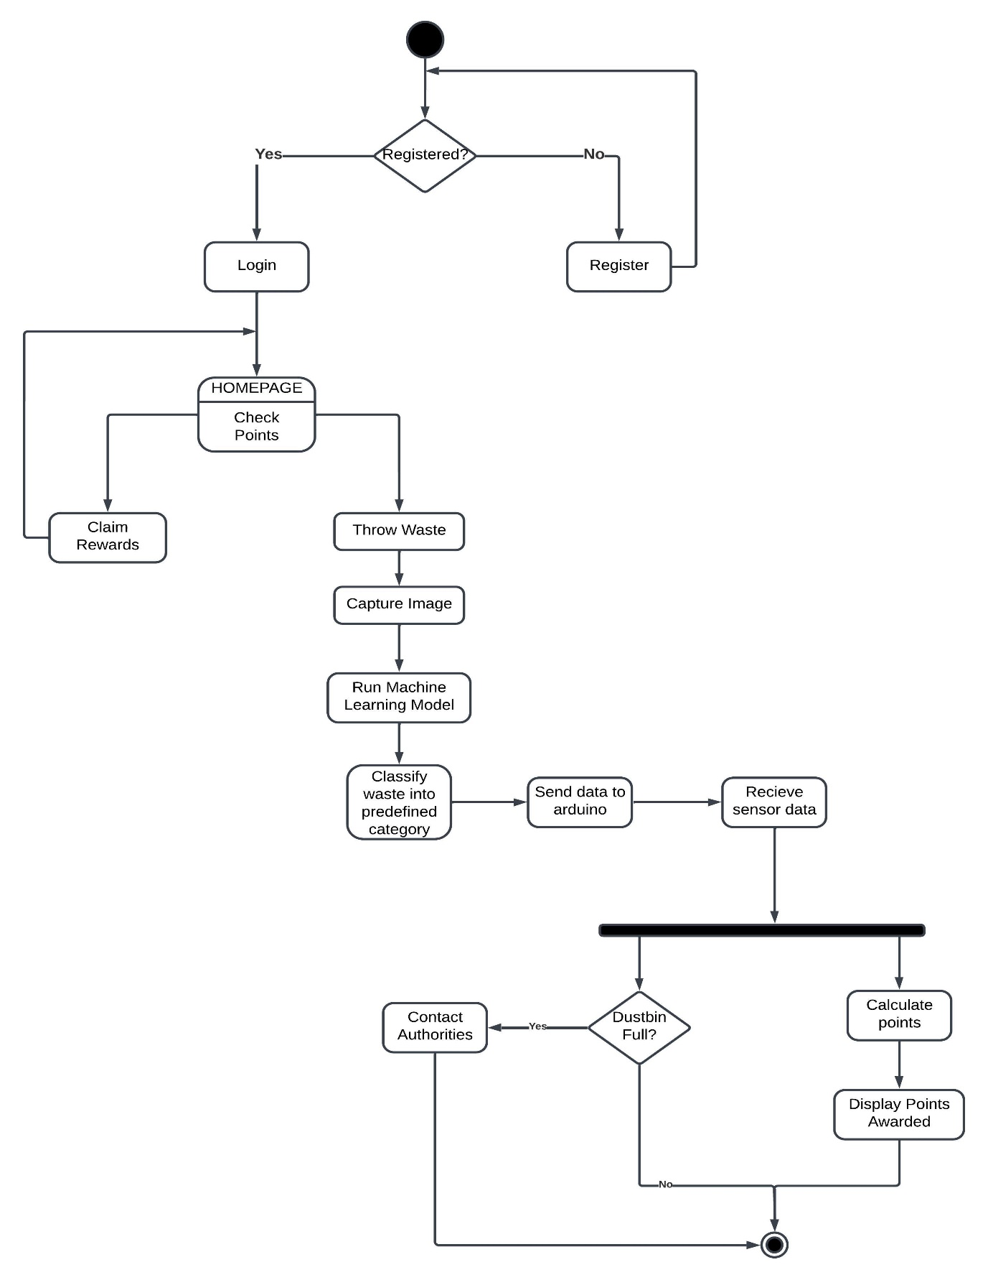**Figure 1. Main Components of Proposed Invention**

**Figure 2. Website Activity Diagram**

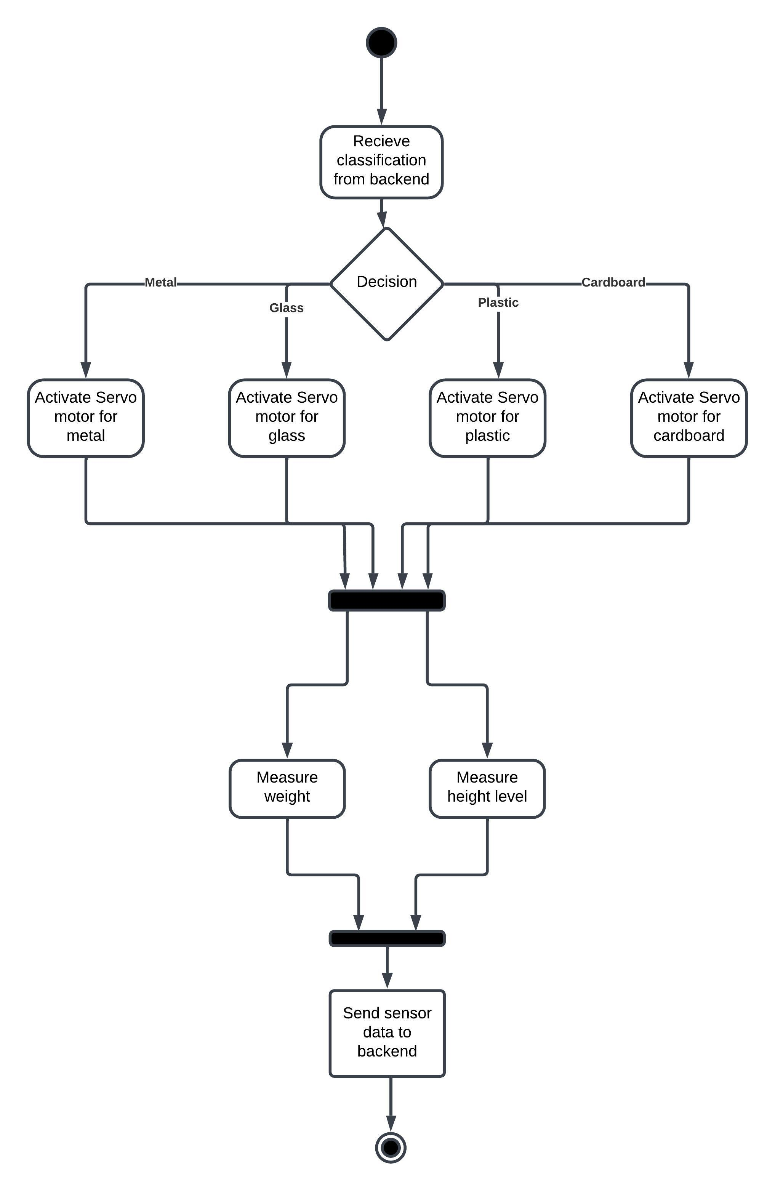

**Figure 3. Arduino Activity Diagram**

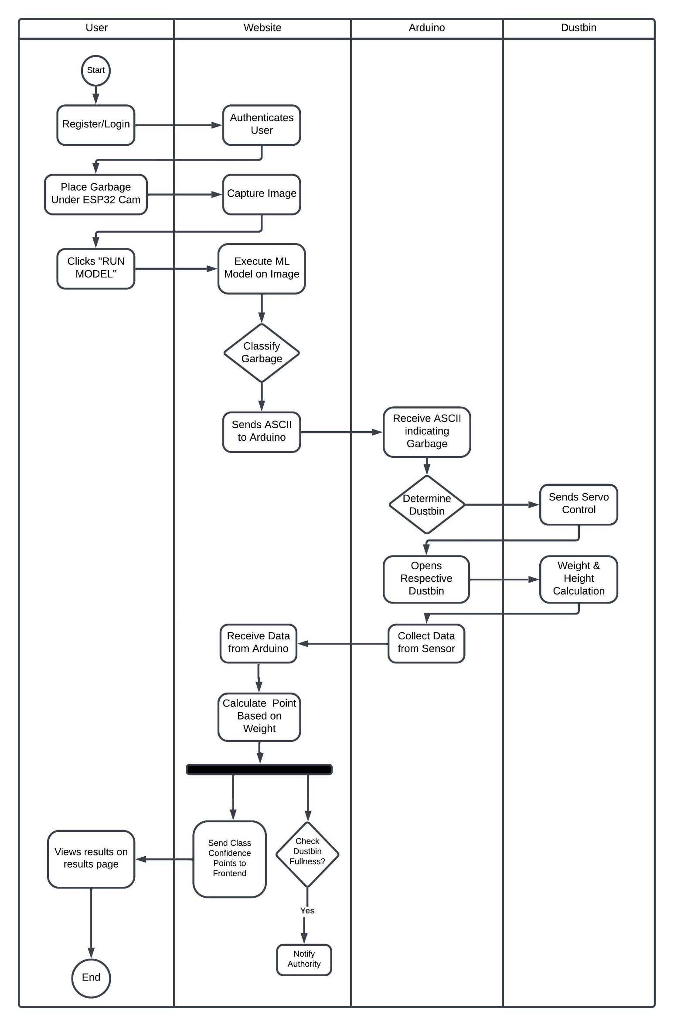

**Figure 4. Swimlane Flowchart Showing the Work of Different Components**

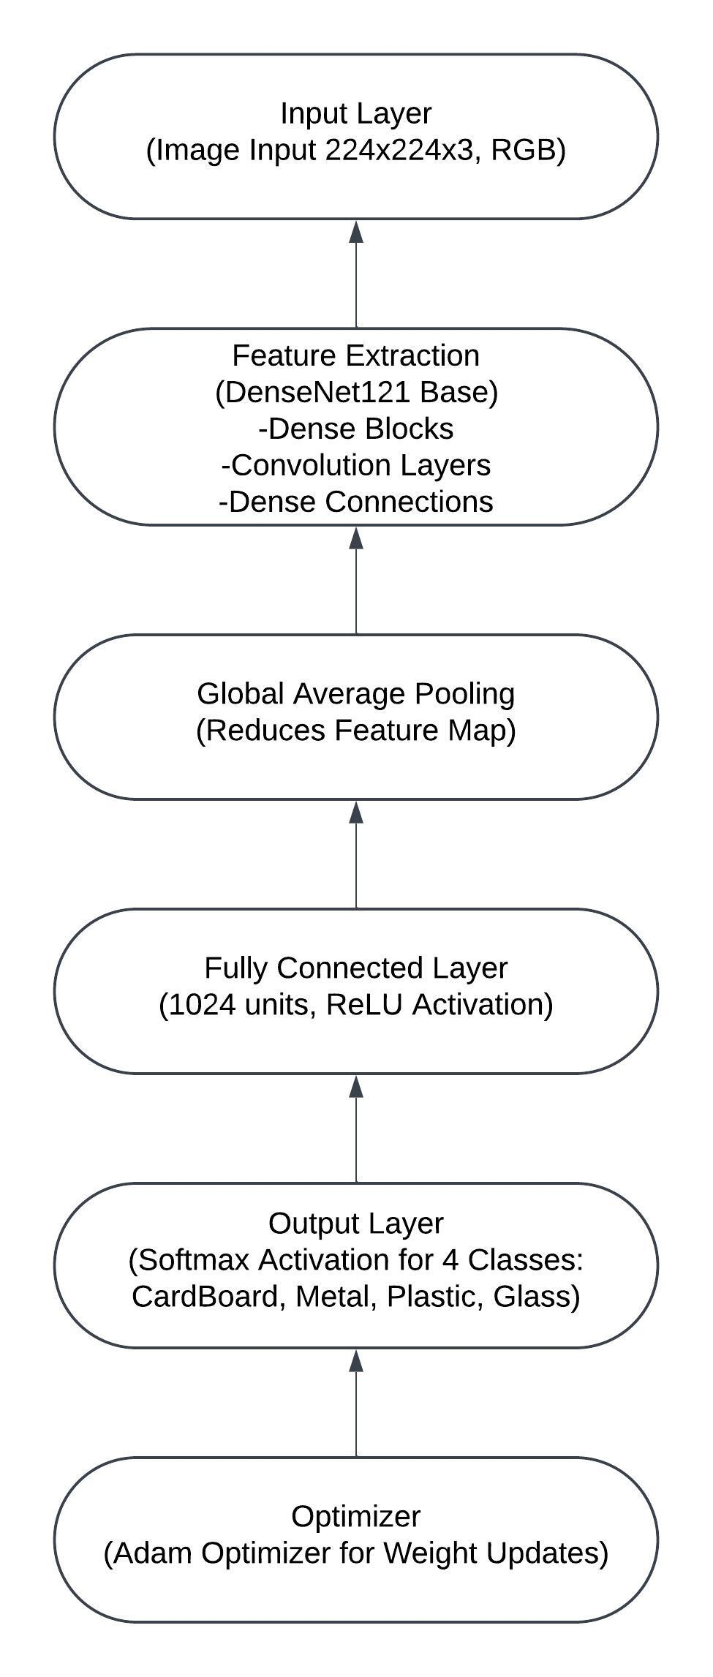

**Figure 5. CNN Layers**

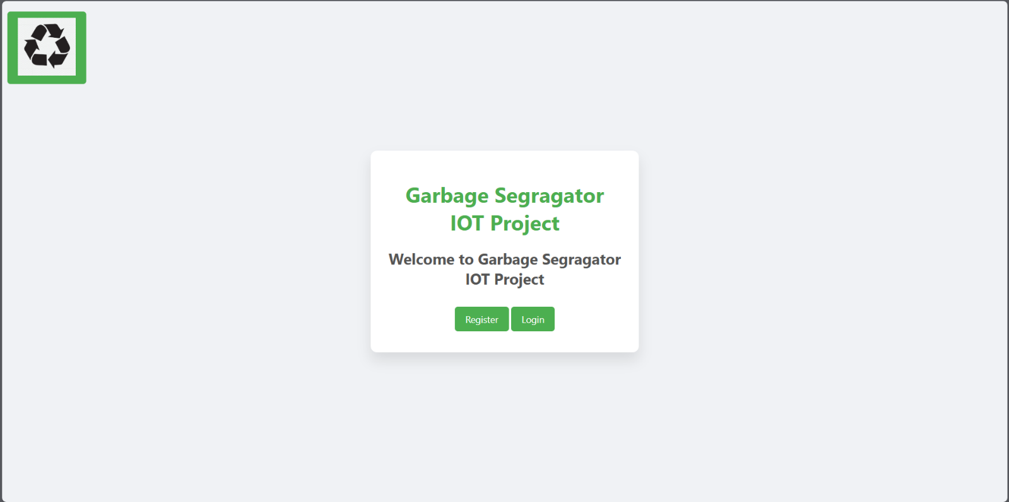

**Figure 6. Website Home Page**

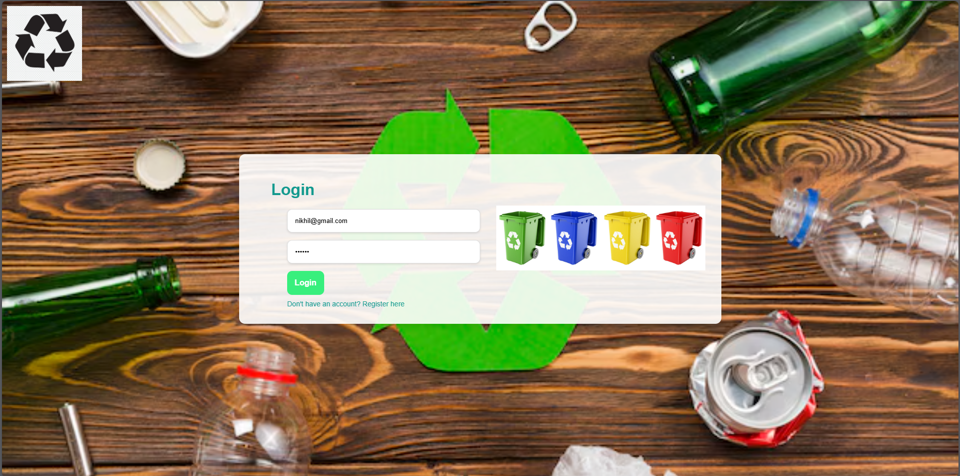

**Figure 7. Website Login Page**

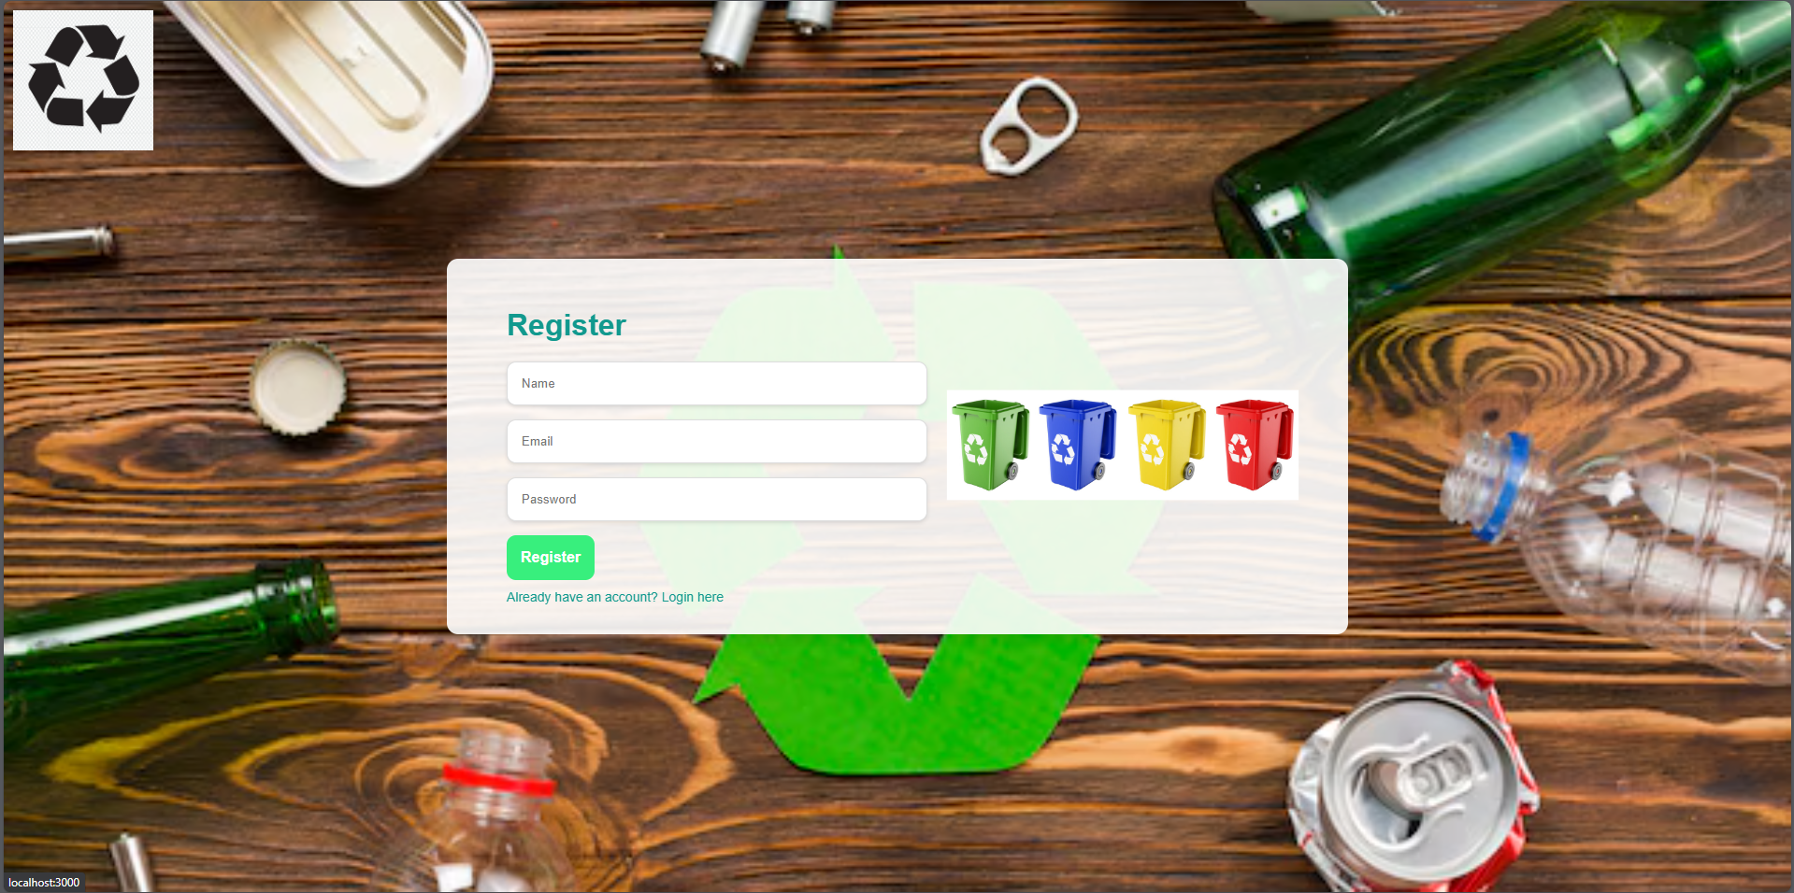

**Figure 8. Website Registration Page**

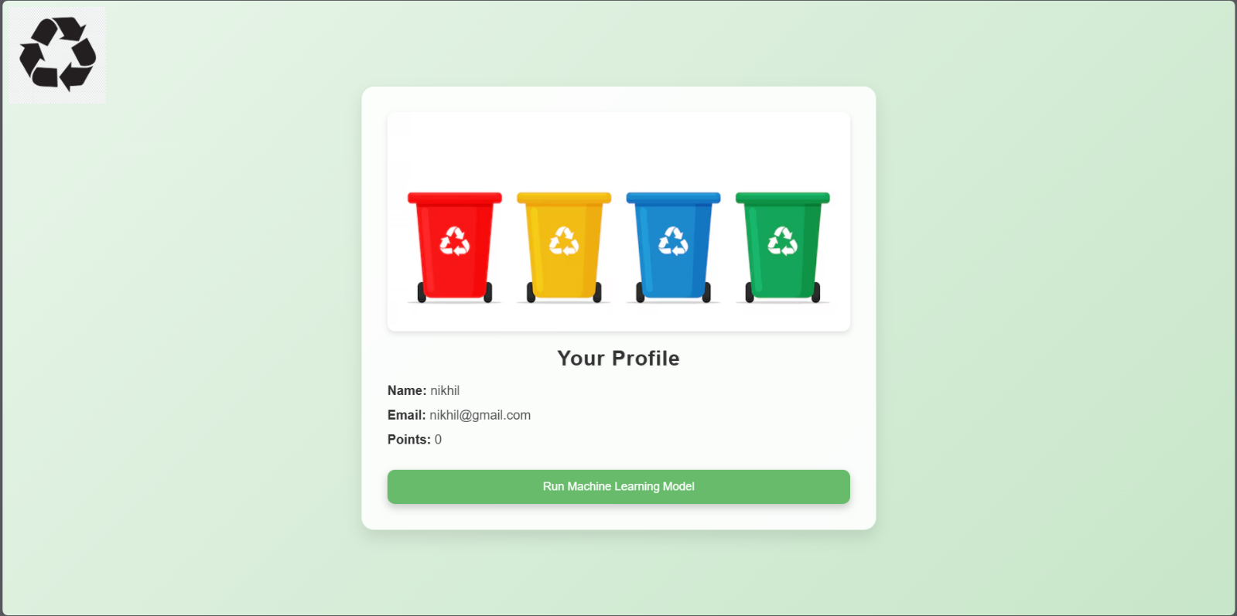

**Figure 9. Website Profile Page**

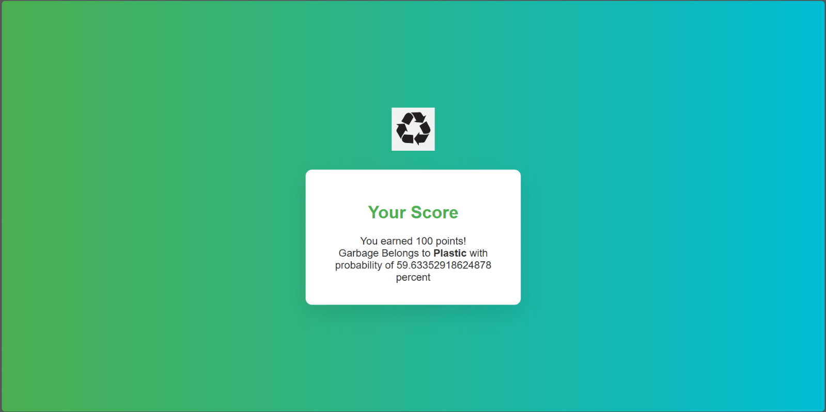

**Figure 10. Website Result Page**

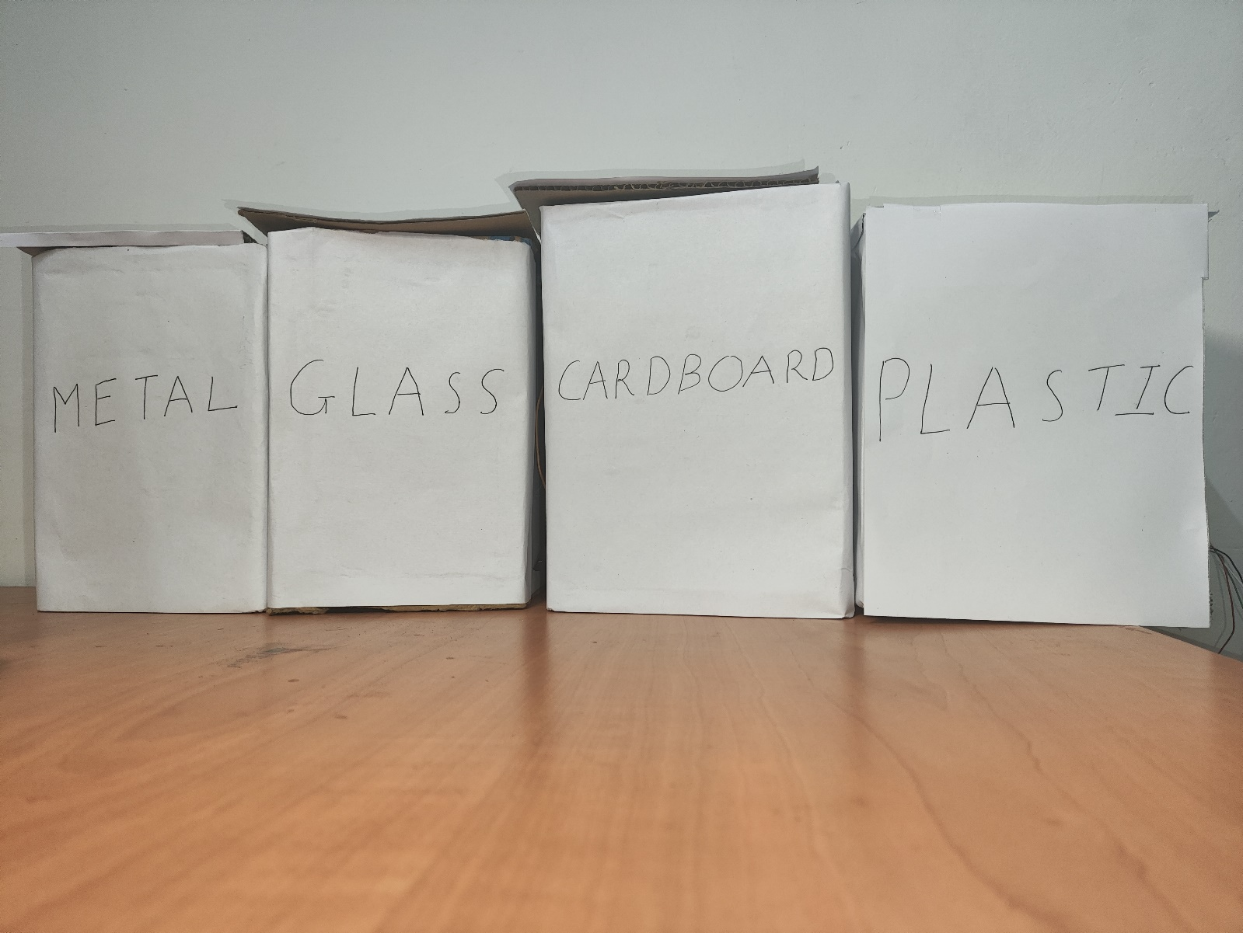**Real-Time Images of Smart Dustbin with Rewards**

**Figure 11. Full View**

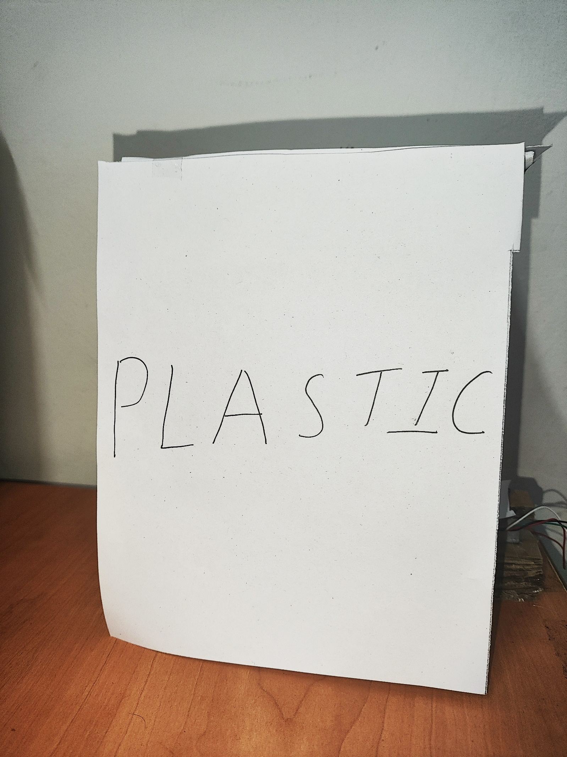

**Figure 12. Front View of Plastic Dustbin**

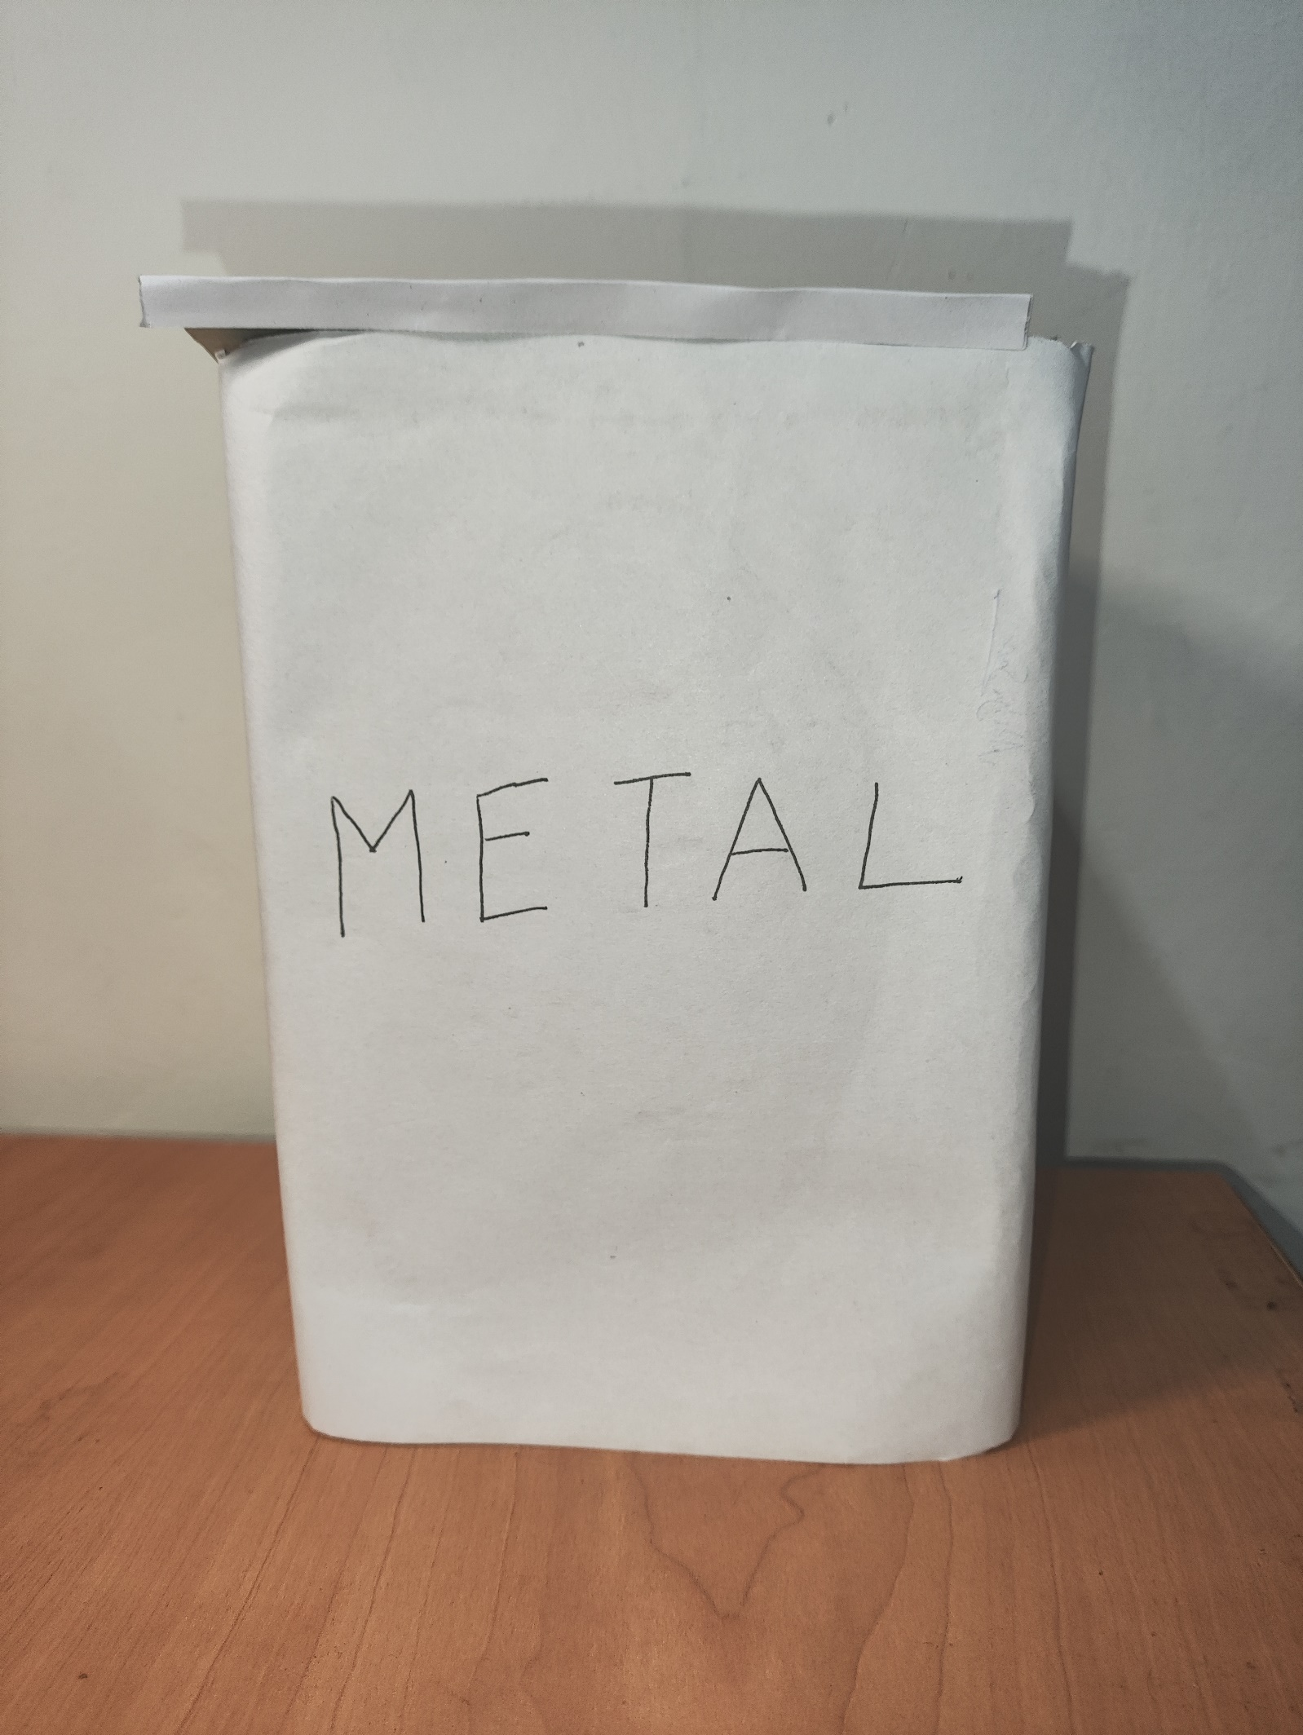

**Figure 13. Front View of Metal Dustbin**

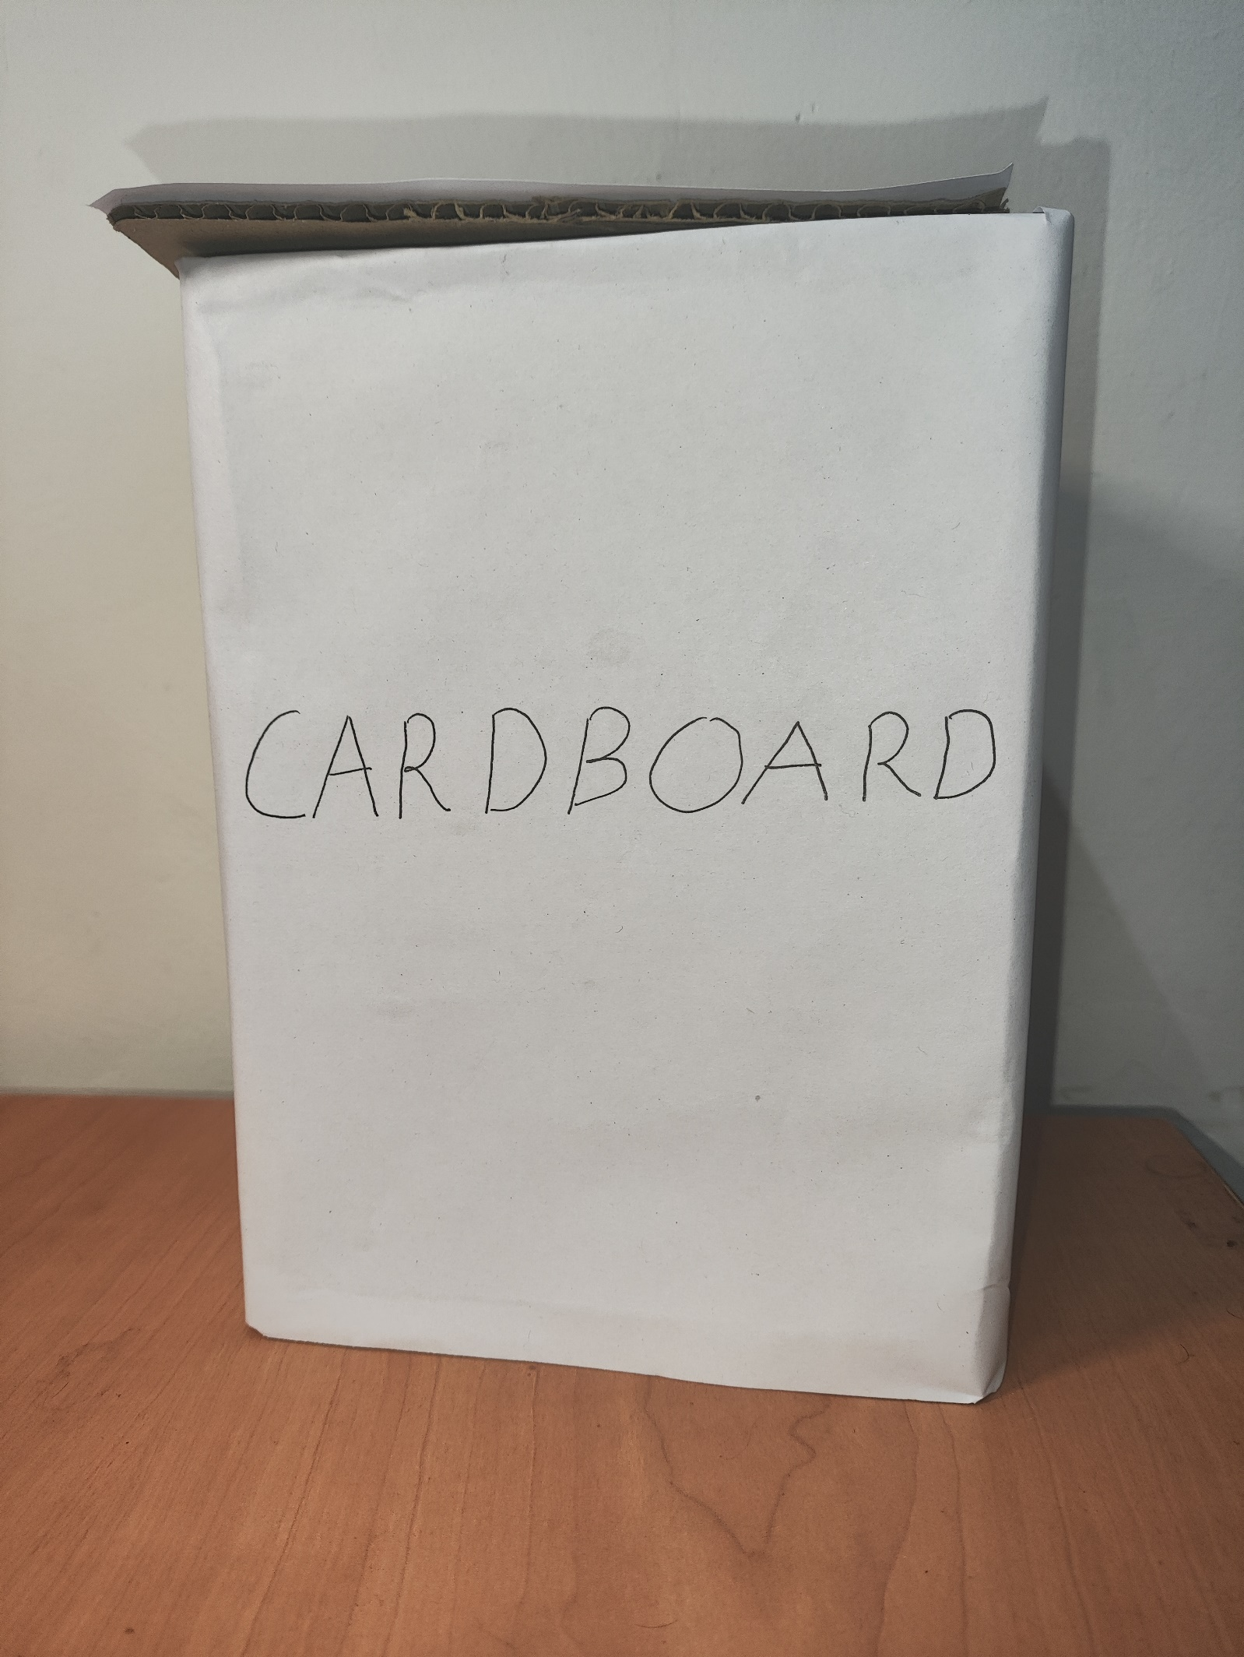

**Figure 14. Front View of Cardboard Dustbin**

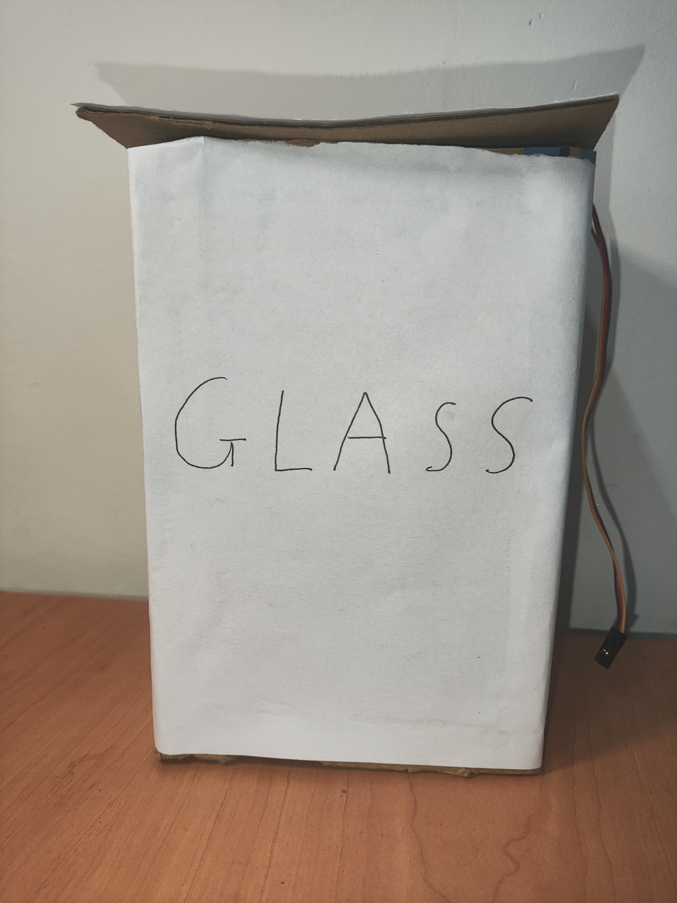

**Figure 15. Front View of Glass Dustbin**

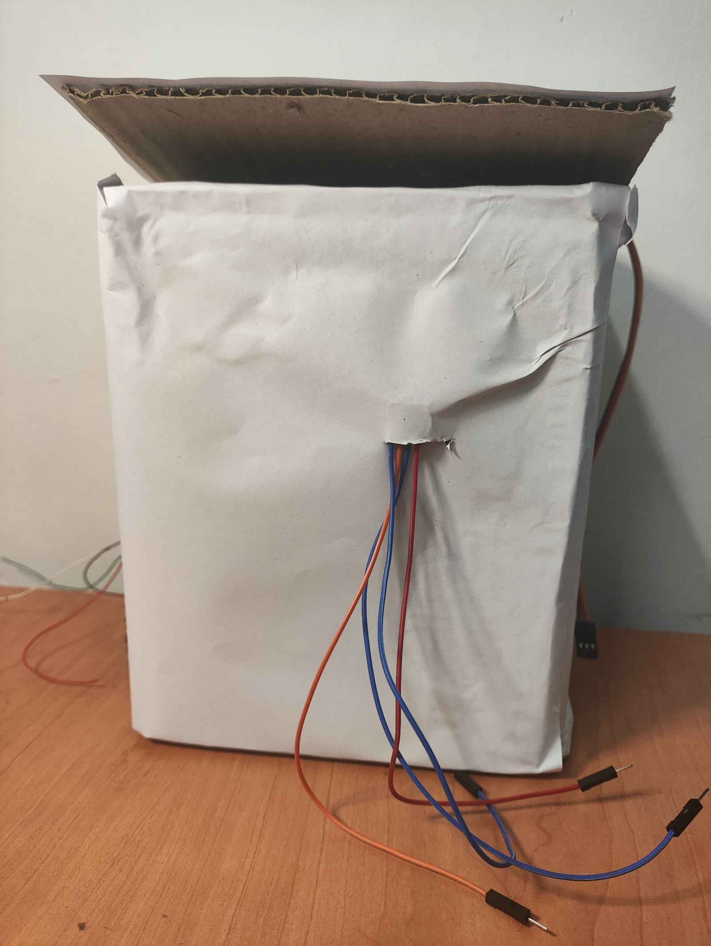

**Figure 16. Rear View of Dustbins**

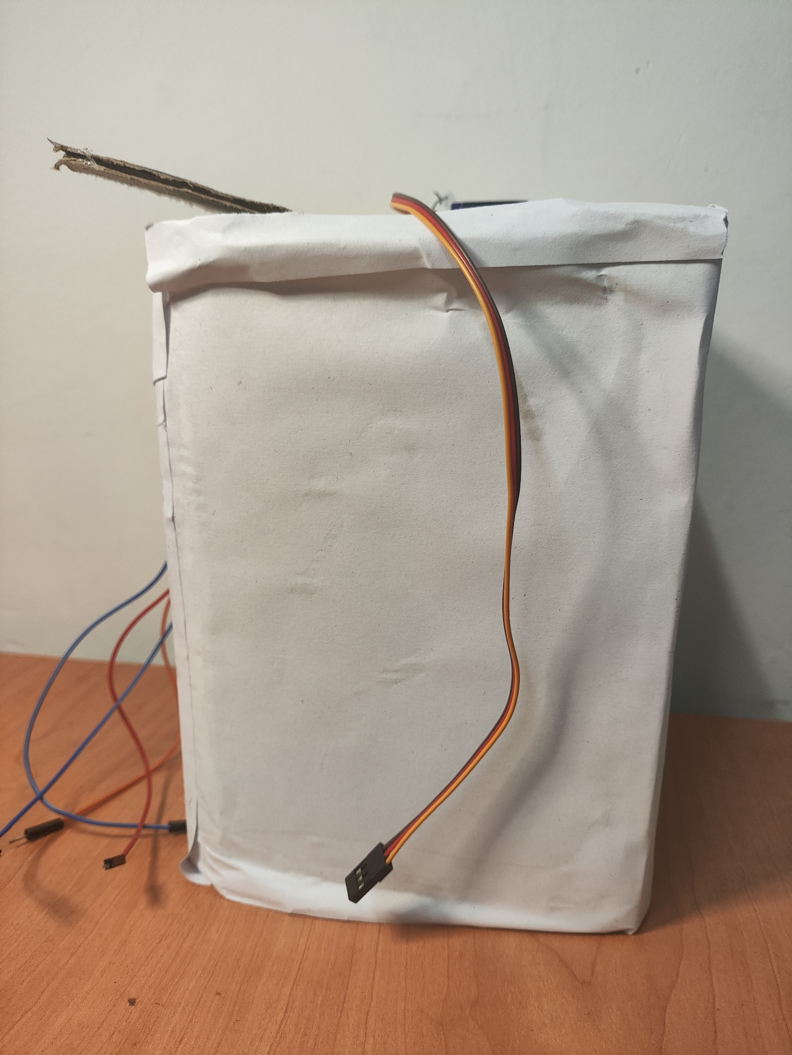

**Figure 17. Right View of Dustbins**

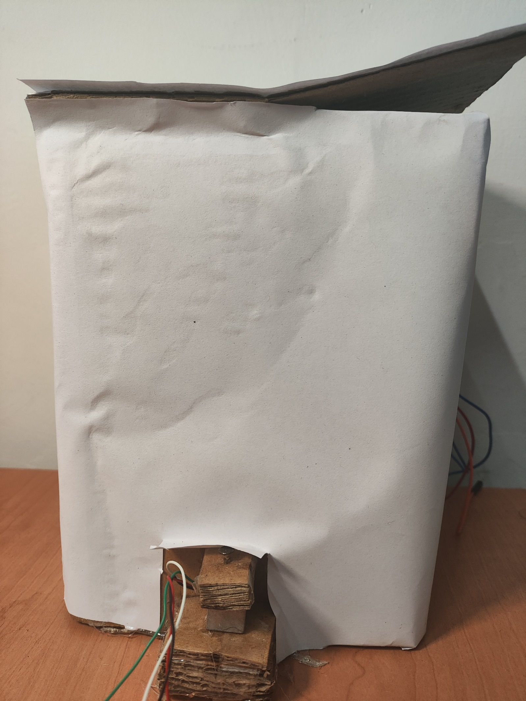

**Figure 18. Left View of Dustbins**

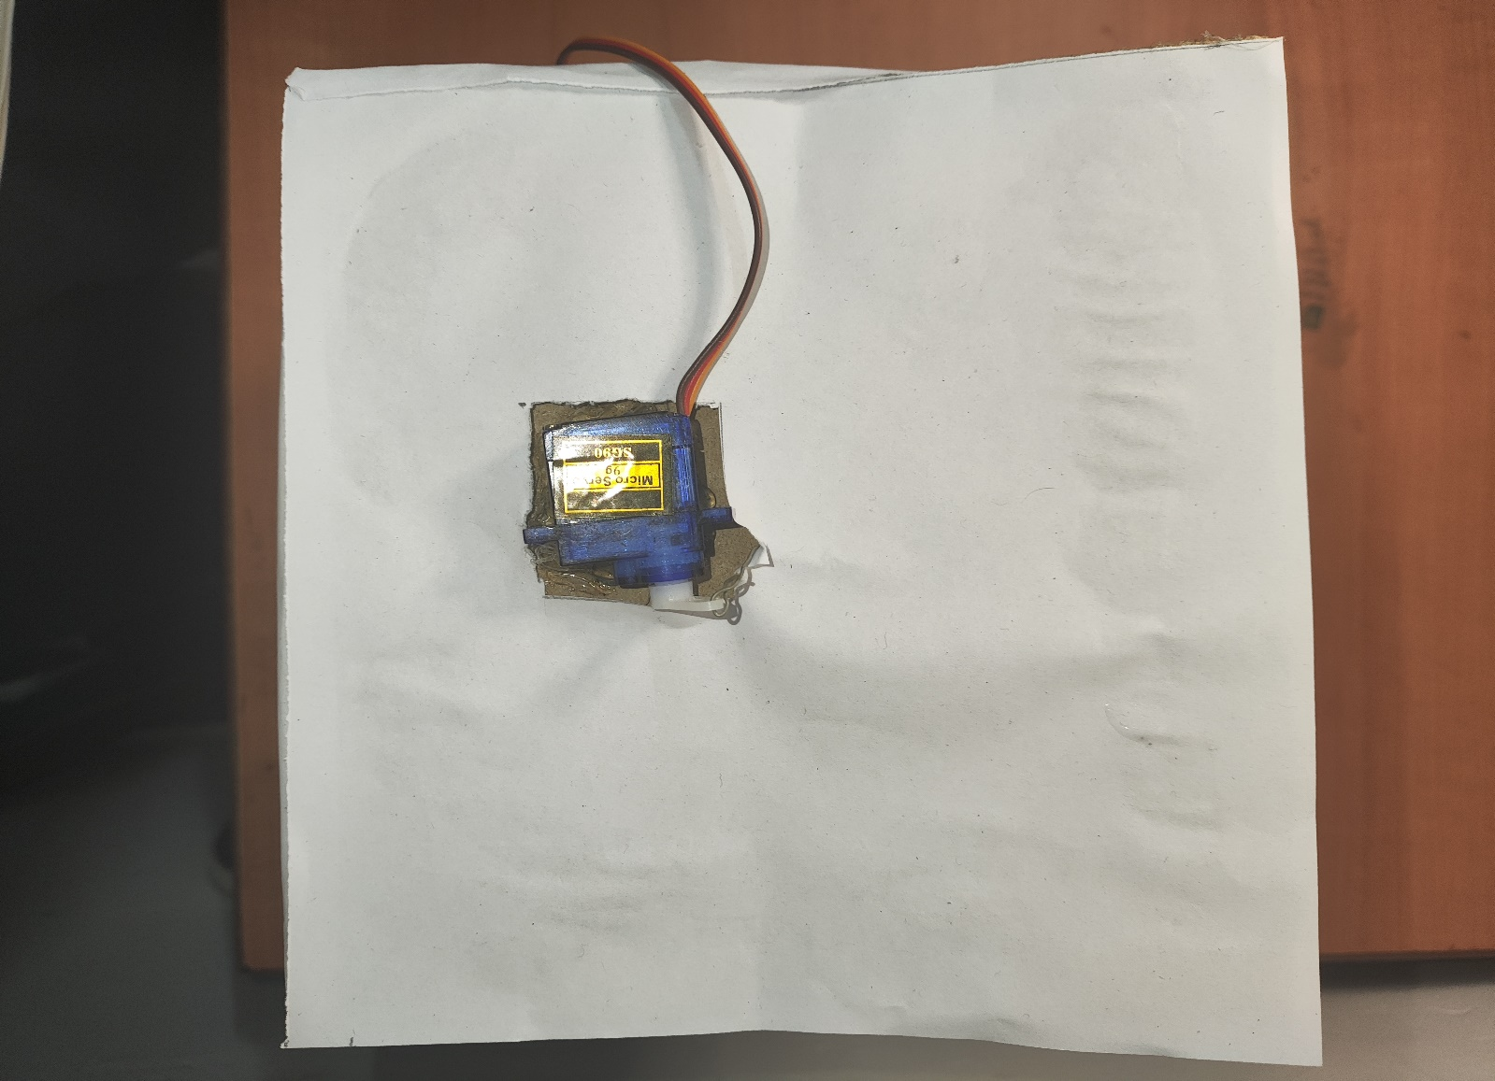

**Figure 19. Top View of Dustbins**

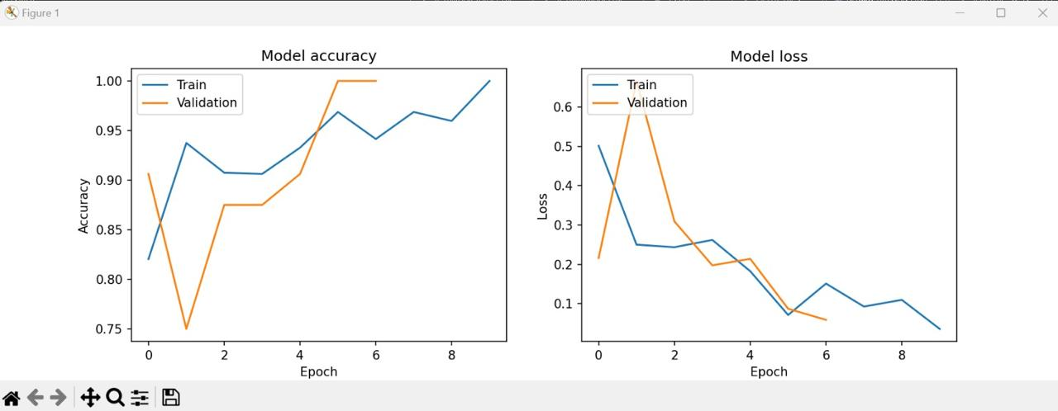

**Figure 20. Model Accuracy and Loss Graph**